

System Requirements Specification

# Crisis Response Ticket System for Shawn Davis by Team Cloud

**Team Members:** David Foster, Jack McGrann, Julie Nau, Patrick Wheeler

**Last updated:** October 4, 2020

# Crisis Response Ticket System

**System Requirements Specification**

**Table of Contents**

**1** **INTRODUCTION**...........................................................................................................4

1.1 PURPOSE OF THIS DOCUMENT ..........................................................................................4

1.2 PURPOSE OF THE PRODUCT ............................................................................................4

1.3 PRODUCT SCOPE .................................................................................................................4

1.4 REFERENCES .......................................................................................................................5

**2 GENERAL DESCRIPTION**..........................................................................................................5

2.1 HIGH LEVEL PRODUCT FUNCTIONS ....................................................................................5

2.2 USER OBJECTIVES ................................................................................................................6

2.3 USER CHARACTERISTICS ....................................................................................................6

2.4 ASSUMPTIONS AND DEPENDENCIES ..................................................................................6

**3 FUNCTIONAL REQUIREMENTS** ................................................................................................7

3.1 INTRODUCTION .....................................................................................................................7

3.2 USE CASES .........................................................................................................................7

**4 NON-FUNCTIONAL REQUIREMENTS**........................................................................................15

4.1 CUSTOMER CONSTRAINTS..................................................................................................15

4.2 EXTERNAL INTERFACES .....................................................................................................15

4.3 OTHER ...................................................................................................................................15

**5 DELIVERABLES** ..................................................................................................................................16

**6 OPEN ISSUES** .....................................................................................................................................16

**7 APPENDIX A – AGREEMENT BETWEEN CUSTOMER AND CONTRACTOR** ......................17

**8 APPENDIX B – TEAM REVIEW SIGN-OFF** ..................................................................................18

**9 APPENDIX C – DOCUMENT CONTRIBUTIONS**.......................................................................... 19

|  |  |  |  |
| --- | --- | --- | --- |
| Version Control | | | |
| Version ID | Date | Change Log | Author |
| 0.1 | 9/25/2020 | Initialized template skeleton | Cloud |
| 0.5 | 9/27/2020 | Combined team efforts and verified document integrity | Cloud |
| 0.8 | 10/2/2020 | Made changes based on feedback from rough draft. | Cloud |
| 1.0 | 10/4/2020 | Finalized rough draft and received approval signature from client. | Cloud |

**1 Introduction**

**1.1 Purpose of This Document**

The purpose of this document is to outline the goals and requirements for a ticket-based emergency response and communication system. This document is intended for use as a reference and guide for the members of our development team and as an overview of the initial design of our ticket-based emergency response application, for the benefit of our professor and our client, Shawn Davis. The scope of the project, including all required functions, will be detailed below.

**1.2 Purpose of the Product**

An application is needed to organize and streamline communication for emergency response services, to better facilitate the allocation of limited resources in emergency management. Due to the time-sensitive nature of emergency events, such as uncontrolled fires, first responders are in need of a system to synthesize quickly and consistently many reports of different origins, and to visualize all current crises and their respective priorities in order to respond efficiently. This need will be met by our Crisis Response Ticket System, through a real-time map of crisis locations and statuses.

**1.3 Product Scope**

As outlined in the following use case diagram, the proposed emergency management system will connect three different types of users to a database of events in need of response: call center operators (1), or those who report crises as they occur in the form of tickets, which are then stored in the ticket database; operations chiefs (2), or those who group tickets together into missions; and mission managers (3), or those who physically respond to the missions based off the designations of the operations chief. A fourth user, the administrator (4), will be responsible for managing other users’ log-ins and permissions; these roles are not mutually exclusive.

The application shall implement a real-time cartographic representation of ongoing emergencies stored in the database, as well as a priority system, to allow ticket managers to determine where to allocate which resources at which time. It shall keep track of each active ticket’s status, and remove tickets when their associated crises have been resolved.

Top Level Use Case Diagram:

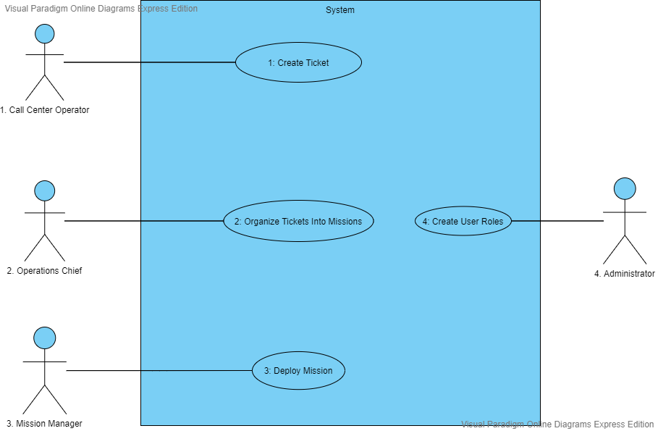

Figure 1.0: Top Level Use Case Diagram

Legend: Stick Figures = Actors, Ovals = Use Cases, Blue Encompassing Box = System as a whole

**1.4 References**

Mitchell, S., Grasso, M., & Joshi, K. (2018, Fall). System Requirements Specification Template. Retrieved September 27, 2020, from

<https://umbc-my.sharepoint.com/:w:/g/personal/kdruffel_umbc_edu/EfsTw6IcT3dMmaDJVqQu70gBDh5Vc3BHfnF9UFej2KNx9g?e=rswcAN>

Druffel, K. (2020, September). 447-00-Timeline-20b. Retrieved September 27, 2020, from <https://umbc-my.sharepoint.com/:x:/g/personal/kdruffel_umbc_edu/EU4VoggR0ihEgVqFVYqbfh8BgSj96iz2EQLeNlxRpX0Ebg?e=91dtyj>

Druffel, K. (n.d.). System Requirements Specification Rubric. Retrieved October 4, 2020, from <https://umbc-my.sharepoint.com/:w:/g/personal/kdruffel_umbc_edu/EYcape0x5btIqYbEDJMo06wB0DL7utPBnWMIUxpEP9gTBQ?e=hngSLm>

**2 General Description**

**2.1 High Level Product Functions**

The software will be required to manage several users. The users are the Call Center Operators (CCO) who create the tickets, the Operations Chief (OC) who manages the tickets, the Mission Managers (MM) who respond to the tickets and the Administrator who manages the system. The software will be able to send accurate ticket information between the four parties, which appropriate modifications when ticket status is updated. The software will also manage a live map that shows ticket locations and changes information based on ticket status.

**2.2 User Objectives**

The customer has hired us to design an emergency response communication and coordination system which must be capable of the following functionalities. The system must be able to organize and store emergency events and information relevant to them in a ticketing system. This system must be able to receive these emergency ticket inputs from the Call Center Operators and allow them to adjust any tickets currently in the system if new information is sent in. The system must also be capable of displaying these tickets in a clear and presentable fashion so that the Operations Chief can group them into missions with assigned equipment and personnel. The software must then provide an interface which allows the Mission Manager to execute and track the missions to completion. Finally, the system must also allow for an administrative role that can act as an implementation and testing role for the system that oversees user role creation.

**2.3 User Characteristics**

User 1 - Call Center Operator: The Call Center Operators are responsible for receiving texts and calls detailing emergency events. The system will provide an interface with input sections for all the relevant information to form a ticket which will then be uploaded to the database of emergency ticket events. This information includes the location, type of emergency, and the time the event was entered.

User 2 - Operations Chief: The Operations Chief will be able to view the tickets uploaded to the database on an interactive map. They will be able to filter the tickets displayed on the map based on the available relevant information that could help the user more easily group the tickets. The Operations Chief is then responsible for choosing which tickets will be grouped together into missions and which service(s) will be needed for each mission and passing this information off to the Mission Manager.

User 3 - Mission Manager: The Mission Manager will receive the list of tickets that are to be grouped into missions and which service(s) will be necessary to handle these missions. The system will provide an interface that will allow the Mission Manager to assign multiple tickets to the same mission and initiate the mission. Each ticket in this mission will share the same mission status, and when tracked through to completion the system will allow the Mission Manager to mark the tickets in the mission as completed and inactive in the system.

User 4 - Administrator: The Administrator will be responsible for creating the user roles and log-ins to the system. The administrator will also be able to log in as each of these roles to ensure that they are able to connect to the correct parts of the system as intended, and to ensure that the connection to the actual system has been correctly created. After ensuring that the roles have been created correctly, they will also grant permission to the Operations Chief to create new Call Center Operator users or Mission Manager users as necessary.

**2.4 Assumptions and Dependencies**

All users will be required to have an internet connection and a device with a browser. The CCO, OC, MM, and Administrator will need basic training before using the product, though the UI will be designed to be intuitive with minimal training. It is assumed that calls will come in to the CCO that they can then turn into tickets in the application. It is assumed that MM will be able to respond to these tickets appropriately and update their status as the situation changes. This program depends on an internet connection between parties to facilitate live and consistent ticket status across all users.

**3 Functional Requirements**

**3.1 Introduction**

This section will visually outline the life cycle flow of each emergency event ticket entered into the software. It will go into further detail from the top-level use case diagram given in section 1.3 about how this process will work. The way we determined the priority scale in sections 3 and 4 for each use case was by collaboratively rating them amongst the development team and our client using a 1 to 5 scale as follows:

|  |  |  |  |  |
| --- | --- | --- | --- | --- |
| 1: Optional | 2: Lower Priority | 3: Requested | 4: Higher Priority | 5: Required |
| Completely optional. Can be done if someone has the ability, but is not a deal breaker if no one is able to. | Must be completed after any higher rated use case. Not functionally required. | The client or professor has emphasized that this would be something they’d like to see but is not functionally required. | Requirements that must be completed first for maximum functional capability. | Must be part of the final product in order for it to qualify as a final deliverable, and/or is the basis for functionality. |

**3.2 Use Cases**

Top Level Use Case Diagram:



Figure 1.0: Top Level Use Case Diagram

Legend: Stick Figures = Actors, Ovals = Use Cases, Blue Encompassing Box = System as a whole

Use Case 1 - Create Ticket:

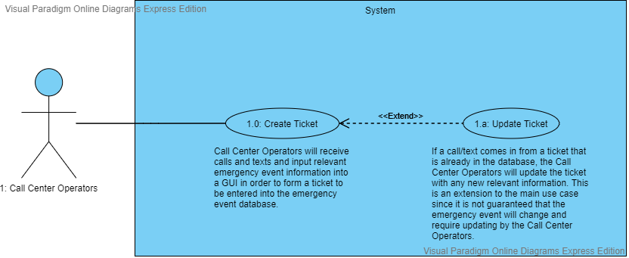

Figure 1.1: Create Ticket Use Case Diagram

Legend: Stick Figures = Actors, Ovals = Use Cases, Blue Encompassing Box = System as a whole

|  |  |
| --- | --- |
| Number | 1 |
| Name | Create Ticket |
| Summary | Call Center Operators will receive calls and texts and input relevant emergency event information into a GUI in order to form a ticket to be entered into the emergency event database. If a call/text comes in from a ticket that is already in the database, the Call Center Operators will update the ticket with any new relevant information. This is an extension to the main use case since it is not guaranteed that the emergency event will change and require updating by the Call Center Operators. |
| Priority |  |
| Preconditions | Emergency Event is Called/Texted into the Call Center |
| Postconditions | An emergency event ticket is uploaded into the database. |
| Primary Actor(s) | Call Center Operators |
| Secondary Actor(s) | People in emergency situations |
| Trigger | Call/Text reporting emergency event |

|  |  |  |
| --- | --- | --- |
| Main Scenario | Step | Action |
|  | 1 | Call/Text is received by the Call Center Operator. The system allows the Call Center Operator to enter all relevant information about the emergency event to form a ticket. |
| Extensions | Step | Branching Action |
|  | 1.a | If a call or text comes in that is in reference to an emergency event ticket already in the system, the system will allow the Call Center Operator to edit any information that needs to be changed. |
| Open Issues |  | Not sure how to host the GUI |

Use Case 2 - Organize Tickets Into Missions:

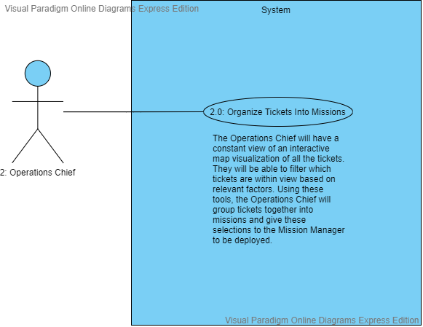

Figure 1.2: Organize Tickets Into Mission Use Case Diagram

Legend: Stick Figures = Actors, Ovals = Use Cases, Blue Encompassing Box = System as a whole

|  |  |
| --- | --- |
| Number | 2 |
| Name | Organize Tickets Into Missions |
| Summary | The Operations Chief will have a constant view of an interactive map visualization of all the tickets. They will be able to filter which tickets are within view based on relevant factors. Using these tools, the Operations Chief will group tickets together into missions and give these selections to the Mission Manager to be deployed. |
| Priority |  |
| Preconditions | Collection of tickets must be uploaded to the system to be displayed to the Operations Chief |
| Postconditions | A set of tickets must be grouped into a mission |
| Primary Actor(s) | Operations Chief |
| Secondary Actor(s) | N/A |
| Trigger | Emergency event tickets start appearing on the interactive map |

|  |  |  |
| --- | --- | --- |
| Main Scenario | Step | Action |
|  | 1 | The system will provide an interactive map visualizing all of the tickets for the Operations Chief to view and use in order to group tickets into missions to give to the Mission Manager. |
| Open Issues |  | How Operations Chief will communicate with the Mission Manager |

Use Case 3 - Deploy Mission:

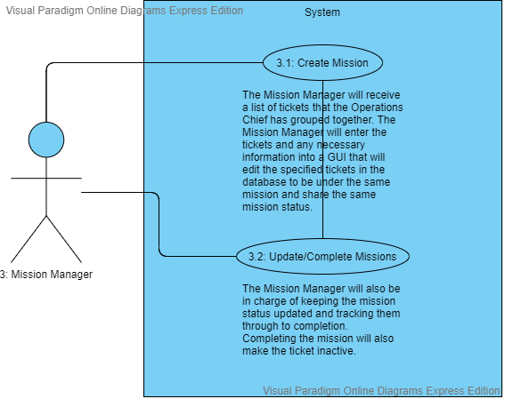

Figure 1.3: Deploy Mission Use Case Diagram

Legend: Stick Figures = Actors, Ovals = Use Cases, Blue Encompassing Box = System as a whole

|  |  |
| --- | --- |
| Number | 3 |
| Name | Deploy Mission |
| Summary | The Mission Manager will receive a list of tickets that the Operations Chief has grouped together. The Mission Manager will enter the tickets and any necessary information into a GUI that will edit the specified tickets in the database to be under the same mission and share the same mission status. The Mission Manager will also be in charge of keeping the mission status updated and tracking them through to completion. Completing the mission will also make the ticket inactive. |
| Priority |  |
| Preconditions | A collection of tickets has been passed from the Operations Chief to the Mission Manager to be executed in a mission. |
| Postconditions | Mission has been tracked and updated to completion and updates tickets accordingly. |
| Primary Actor(s) | Mission Manager |
| Secondary Actor(s) | Operations Chief |
| Trigger | Must receive grouping of tickets from Operations Chief to deploy into a mission. |

|  |  |  |
| --- | --- | --- |
| Main Scenario | Step | Action |
|  | 1 | The system will provide an interface that will allow the Mission Manager to assign a group of tickets to a mission and begin the mission execution. |
|  | 2 | The system will allow the Mission Manager to track and follow the missions to completion, and mark them as inactive when they reach this point. |
| Open Issues |  | Not sure to what extent the Mission Manager will be actively tracking each mission |

Use Case 4 - Create User Roles:

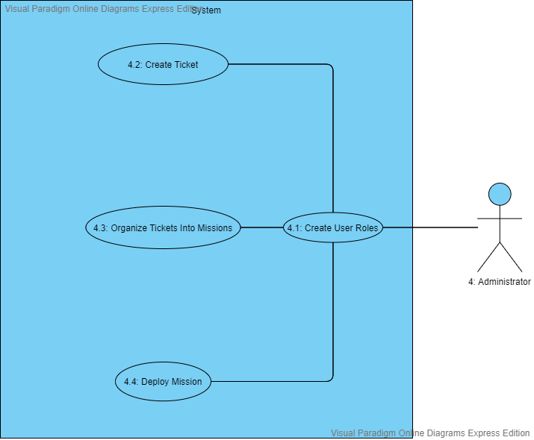

Figure 1.4: Create User Roles Use Case Diagram

Legend: Stick Figures = Actors, Ovals = Use Cases, Blue Encompassing Box = System as a whole

|  |  |
| --- | --- |
| Number | 4 |
| Name | Create User Roles |
| Summary | The Administrator will be able to create user roles and give them the necessary rights to access the system, and grant user creation privileges to the Operations Chief as well. The administrator will also be implementing and testing the creation and use of the user roles and use cases. |
| Priority |  |
| Preconditions | The necessary roles for the different users aren’t available in the system and the users are not able to connect to the system. |
| Postconditions | User roles will be established as part of the system and given access to the part of the system they are meant to interact with. All user roles have been implemented and tested and are able to function as they have been described. |
| Primary Actor(s) | Administrator |
| Secondary Actor(s) | Operations Chief |
| Trigger | Project Development, Implementation and Testing |

|  |  |  |
| --- | --- | --- |
| Main Scenario | Step | Action |
|  | 1 | The system will allow the Administrator to create the necessary log-ins and access permissions to the system for the other three user roles. |
|  | 2 | The Administrator will be able to log in as a Call Center Operator to test that they have correct access capabilities to the system. |
|  | 3 | The Administrator will be able to log in as the Operations Chief to test that they have correct access capabilities to the system. |
|  | 4 | The Administrator will be able to log in as a Mission Manager to test that they have correct access capabilities to the system. |
| Open Issues |  |  |

**4 Non-Functional Requirements**

Priority Descriptions

|  |  |  |  |  |
| --- | --- | --- | --- | --- |
| 1: Optional | 2: Lower Priority | 3: Requested | 4: Higher Priority | 5: Required |
| Optional; implementation possibly out of scope. | Would provide benefit, but remains unessential. | Necessary to comply with client’s and/or professor’s product standards. | Essential in maintaining the performant, secure, and consistent nature of the system. | Integral to the core system; dependent on functionality and required by design. |

**4.1: Customer Constraints**

**4.1.1: Priority 3**

The system shall be a two-tier web application.

**4.2: External Interfaces:**

**4.2.1: Priority 2**

The system will provide 24/7 on-call support to respond to system outages.

**4.2.2: Priority 3**

The system shall be compatible with both desktop and mobile web browsers.

**4.2.3: Priority 4**

Maintain Failover site and required software infrastructure at alternate sites within the Enterprise

**4.2.4: Priority 4**

Develop plans and procedures to support 98% availability of all systems and subsystems.

**4.2.5: Priority 5**

The system shall support up to 10,000 concurrent users.

**4.3: Other:**

**4.3.1: Priority 1**

The system shall return metrics regarding application availability, concurrent users, and performance.

**4.3.2: Priority 3**

During emergencies, the system’s database will be backed up every 5 minutes.

**4.3.3: Priority 4**

System shall support single sign-on.

**5 Deliverables**

|  |  |  |
| --- | --- | --- |
| **Deliverable** | **Format** | **Estimated Due Date** |
| Copies of Biweeky Status Report | PDF | Biweekly beginning 10/1 |
| README | PDF | December 1st |
| System Requirement Specification | PDF | October 4th |
| System Design Document | PDF | October 22nd |
| User Interface Design Document | PDF | October 22nd |
| Midterm Demo | Presentation | October 27 / October 29 |
| Code Inspection Report | PDF | November 3rd |
| Test Report | PDF | November 12th |
| User Manual | PDF | November 24th |
| Administrator Manual | PDF | November 24th |
| All source code | Code files | November 24th |
| Executable Program | Web program files | December 1st |
| Final Demo | Presentation | December 1-12th |

**6 Open Issues**

List and briefly discuss issues that do not yet have a conclusion. Give specific target resolution dates. Be honest.

|  |  |  |
| --- | --- | --- |
| Issues | | |
| Number | Description | Target Fix Date |
| 1 | Need to firmly establish programming tools across team members for consistent project deliverables. | 10/07/2020 |

**7 Appendix A – Agreement Between Customer and Contractor**

By signing this document you agree that the information presented in this document is true to the best of your knowledge and that the actions and that this represents the wishes of both parties.

If there are any changes to be made to the document, an audit report of the changes will be available to both parties to review with weekly meetings to discuss changes. Backups of previous versions will be available if a change needs to be rolled back.

|  |  |  |
| --- | --- | --- |
| **Typed Name** | **Electronic Signature** | **Date Signed** |
| David F | David Foster | 9/27/20 |
| Jack M | John McGrann | 9/27/20 |
| Julie N | Julia Nau | 9/27/20 |
| Patrick W | Patrick Wheeler | 9/27/20 |
| Shawn D | Shawn Davis | 10/4/20 |

Customer comments written here:

**Nice job incorporating all of our discussion last week. Well done.**

**8 Appendix B – Team Review Sign-off**

By signing below, all team members have reviewed the document and agree on its content and format. The comment section is to be used for minor unresolved issues.

|  |  |  |  |
| --- | --- | --- | --- |
| **Typed Name** | **Electronic Signature** | **Date Signed** | **Comments** |
| David F | David Foster | 9/27/20 |  |
| Jack M | John McGrann | 9/27/20 |  |
| Julie N | Julia Nau | 9/27/20 |  |
| Patrick W | Patrick Wheeler | 9/27/20 |  |

**9 Appendix C – Document Contributions**

As Requirements leader, Julie N. is in charge of this document.

|  |  |  |
| --- | --- | --- |
| **Team Member** | **Contribution** | **Estimated Percent Work** |
| David F | Cover page, 2.1, 2.4, 5, 7, 8 | 25% |
| Jack M | 2.2, 2.3, 3.1, 3.2 | 30% |
| Julie N | 1.1, 1.2, 1.3, 1.4, 7, 8 | 25% |
| Patrick W | 4.1, 4.2, 4.3 | 20% |